Justify Your Attendance Kit for
Learning Forward’s Virtual 2021 Annual Conference

Table of Contents
Talking points 2 Sample letter: Request for approval 3 Benefits to district 4 Who attends 4 Pricing 5 Alternative funding options 5 Learning First Alliance letter 6

Talking points
- Explain specifically what you plan to learn by attending the conference and how that will benefit your peers and the students in your school or district.

- In addition to your personal learning goals, here are other popular reasons to attend:
  - Network with other education professionals experiencing similar challenges;
  - Stay on top of best practices from leaders in the field;
  - Small one-on-one learning experiences, even though at an international conference;
  - Take new knowledge and understanding of the latest research back to schools to make change; and
  - Experience dynamic, interactive learning experiences that rejuvenate and refresh educators at all levels.

- Show how you will share the learning with your team and when you return.
  - Share session presentations and handouts;
  - Write summaries and analyses;
  - Create a slideshow presentation or video;
  - Develop poster presentations;
  - Utilize technology that you learn about at the conference;
  - Model learning strategies you discover;
  - Volunteer to host mini workshops; or
  - Plan sharing opportunities across grade levels, subject areas, and schools.

- Be proactive
  - Avoid the nonmember registration fee by joining Learning Forward or renewing your Learning Forward membership.

Sample letter: Request for approval

Dear Colleague,
I am writing to request approval to attend the Virtual Learning Forward Annual Conference this December 5-7.
[Explain specifically what you plan to learn by attending the conference and how that will benefit your peers and the students in your school or district.]
Example: As you know, our professional learning goals this year include developing personalized instruction and data-based program evaluation. Learning Forward’s virtual conference offers sessions on (list of topics), plus 100 sessions focused on other areas of need.
Here are some other advantages to attending this conference:
- Networking with other educators who are experiencing similar challenges;
- Staying on top of best practices from leaders in the field;
- Seeing first-hand the kinds of dynamic, interactive learning experiences that rejuvenate and refresh educators at all levels.
[Describe how you plan to share the learning upon your return.]
Upon my return, I plan to share my learning with my team and other staff as needed. I can do so by sharing session presentations, handouts, and written summaries. I can also utilize technology that I learn about, model learning strategies I discover, and host mini workshops across grade levels, subject areas, and schools.
The cost of the conference ranges from $153 - $234 per day.

I can save on costs by becoming a Learning Forward member and it would save up to $123. I look forward to your response.

Thank you, [name]

Benefits to district
Effective professional learning remains the single most powerful investment a district can make for improving educator effectiveness to increase student achievement.
The conference offers a district’s education leaders
- Connections;
- Tools;
- Learning opportunities; and
- Resources needed to design, implement, and measure high-quality professional learning for educator and student success.

Who attends the Learning Forward Annual Conference?

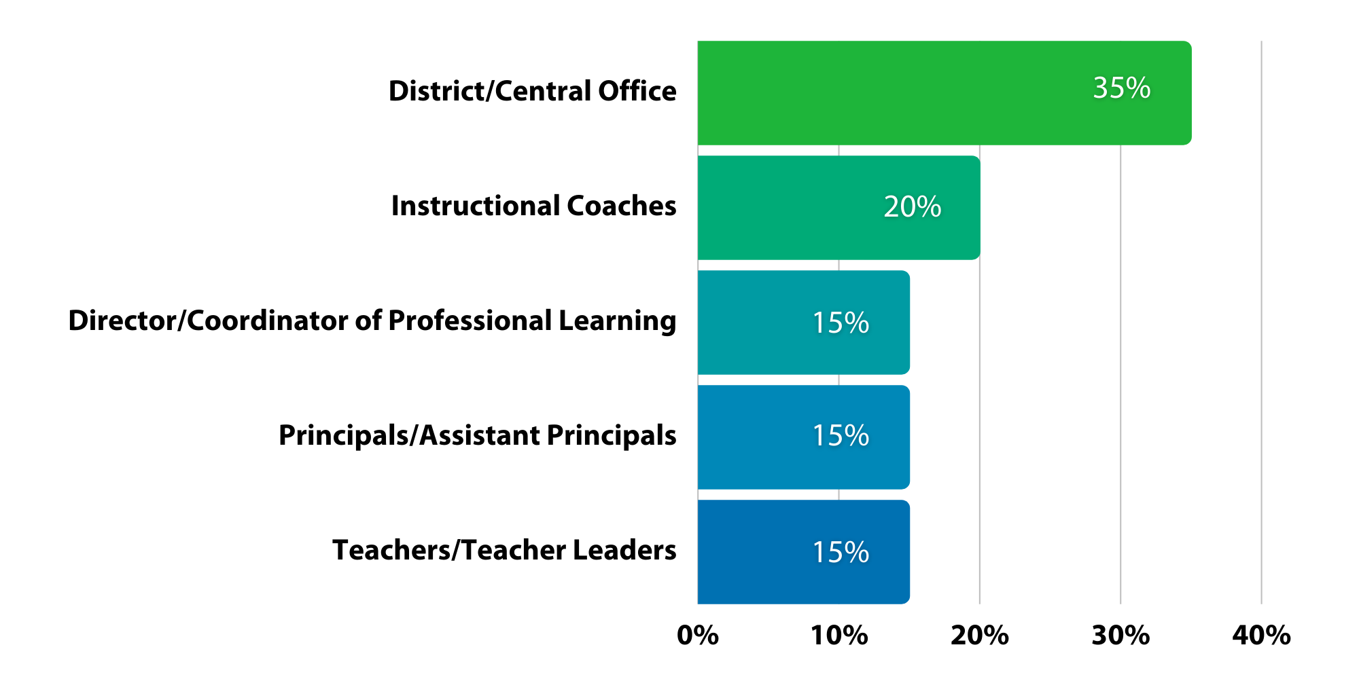

Registration

 | 5/1/2021 – 8/2/2021 |  | 8/3/2021 – 11/1/2021 |  | 11/2/2021 – 12/7/2021
 | Early Bird |  | Early |  | Regular & Onsite
 | Member | NonMember | Member | NonMember | Member | NonMember
Sunday  PreCon  Dec 5 | $168 | $209 | $183 | $224 | $193 | $234
Monday  Conf  Dec 6 | $153 | $194 | $168 | $209 | $178 | $219
Tuesday  Conf  Dec 7 | $153 | $194 | $168 | $209 | $178 | $219

Alternative funding options
Seek out grants from organizations you belong to, including state or provincial education agencies, PTA/PTO, religious institutions, Kiwanis or Rotary Clubs, etc.

Here are some organizations to help find grants:
- The Grants.gov program management office was established, in 2002, as a part of the President's Management Agenda. Managed by the Department of Health and Human Services, Grants.gov is an E-Government initiative operating under the governance of the Office of Management and Budget. https://www.grants.gov
- GrantSelect is an online database of funding opportunities such as grants (for programs, projects, planning, start- up, endowments, technical assistance, facilities and equipment, etc.), awards, and fellowships for example. https://www.grantselect.com
- Dedicated GrantWatch researchers and grant associates, publish the newest grants and letters of inquiry (daily) and archive the grants with past funding dates. Government agencies, foundations, and corporations post the details of their funding opportunity for free through their dedicated portal. https://www.grantwatch.com/grant- search.php
- ENGLISH LANGUAGE ACQUISITION STATE GRANTS http://www2.ed.gov/programs/sfgp/index.html?exp=0
- The Teacher Quality Partnership (TQP) grant program, authorized in Title II of the Higher Education Act, is the only federal initiative designed to strengthen and reform educator preparation at institutions of higher education. https://aacte.org/policy-and-advocacy/federal-policy-and-legislation/435-teacher-quality-partnership-grants
- Special Education -- State Personnel Development Grants Program https://www2.ed.gov/programs/osepsig/index.html
- Special Education--Personnel Development to Improve Services and Results for Children with Disabilities https://www2.ed.gov/programs/osepprep/index.html

