
Justify your attendance kit for Learning Forward’s conference

Table of Contents
Sample letter: Request for approval 2
Talking points 3
Topics covered 4
Role-specific tracks 5
Benefits to district 5
Who attends 6
Early Registration pricing 6
Alternative funding options 6
Schedule at a glance 7

Sample letter: Request for approval

Dear Colleague,

I am writing to request approval to attend the Learning Forward Annual Conference this December 2-6.

[Explain specifically what you plan to learn by attending the conference and how that will benefit your peers and the students in your school or district.] Example: As you know, our professional learning goals include developing personalized instruction and data-based program evaluation. Learning Forward’s conference is the only place where I can easily attend more than 12 sessions on just these two topics, plus more than 300 sessions focused on other areas of need.

Here are some other advantages to attending this conference:

Networking with other education experiencing similar challenges;

Staying on top of best practices from leaders in the field;

Seeing first-hand the kinds of dynamic, interactive learning experiences that rejuvenate and refresh educators at all levels.

Upon my return, I plan to share my learning with my team and other staff as needed. I can do so by sharing session presentations, handouts, and written summaries. I can also utilize technology that I learn about, model learning strategies I discover, and host mini workshops across grade levels, subject areas, and schools.

The cost of the conference is approximately $190 per day and includes lunches and some breakfasts. Right now, the cost to fly is only _____. Including hotel, I estimate the total cost to be ______. I can save on costs by booking my travel early and registering with the members-only rates, so I look forward to your response.

Thank you,

[name]

Talking points

- Explain specifically what you plan to learn by attending the conference and how that will benefit your peers and the students in your school or district.

- In addition to your personal learning goals, here are other popular reasons to attend:
- Network with other education professionals experiencing similar challenges;
- Stay on top of best practices from leaders in the field;
- Small one-on-one learning experiences, even though at an international conference;
- Take new knowledge and understanding of the latest research back to schools to make change; and
- Experience dynamic, interactive learning experiences that rejuvenate and refresh educators at all levels.

- Show how you will share the learning with your team and when you return.
- Share session presentations and handouts;
- Write summaries and analyses;
- Create a slideshow presentation or video;
- Develop poster presentations;
- Utilize technology that you learn about at the conference;
- Model learning strategies you discover;
- Volunteer to host mini workshops; or
- Plan sharing opportunities across grade levels, subject areas, and schools.

- Be proactive
- Offer to share a room to reduce hotel expenses;
- Book your travel early; and
- Avoid the nonmember registration fee by joining Learning Forward or renewing your Learning Forward membership.

Topics covered

Areas of focus
Learning Communities
Leadership
Resources
Data
Learning Designs
Implementation
Outcomes – Educator and Student Learning
Technology
Equity
Global / Emerging Issues

Other topics
Addressing change and resistance
Adult development and learning
Allocating resources for professional learning
Assessment and grading
Brain-based strategies
Career pathways
Coaching and school coaches
Collaborative inquiry
College- and career-readiness/student performance
Communities of Practice / Personal Learning Networks
Continuous improvement
Culturally responsive pedagogy
Culture and climate
Data-driven decision making
Differentiated instruction
Educator Effectiveness Measures
Equity
ESSA - Every Student Succeeds Act
Family and community engagement
Future-ready learning
Global perspectives
Instructional leadership and supervision
Integrating student or teacher voice
Leadership development and skills
Linguistic diversity/English language learners
Literacy
Mentoring and induction
Models of professional learning
Motivating/Engaging disenfranchised learners
Observation and feedback strategies
Online or blended learning
Other
Partnerships and coalition building
Policy development and advocacy efforts
Presentation and facilitation skills
Principal mentoring and/or coaching
Program evaluation
Project- or Challenge-based learning (PBL)
Response-to-Intervention
Rural issues and settings
School / System reform/improvement process
Social and emotional learning (SEL)
Social networking applications
Standards for Professional Learning Forward
STEM: Science, technology, engineering, and math
Teacher recruitment, support, development, and retention
Title I / Economically disadvantaged population
Urban issues and settings
Use of technology for professional learning
Use of technology to enhance student learning
Walk-throughs/Instructional Rounds

Role-specific tracks
Browse sessions by topic, set, presenter, and by audience. Choose the best sessions for your role, for instance:
- Sessions for Superintendents
- Sessions for Academic Officers
- Sessions for Policymakers
- Sessions for Title I Schools

Benefits to district

Effective professional learning remains the single most powerful investment a district can make for improving educator effectiveness to increase student achievement.
The conference offers a district’s education leaders
- Connections;
- Tools;
- Learning opportunities; and
- Resources needed to design, implement, and measure high-quality professional learning for educator and student success.

Who attends
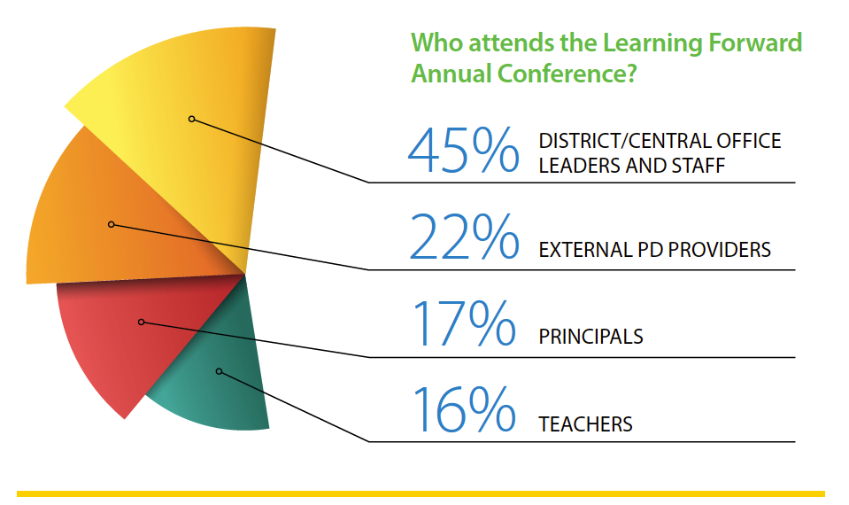

Early Registration pricing

Dates Member Nonmember
Saturday, Dec. 2 $190 $202
Sunday, Dec. 3 $190 $202
Monday, Dec. 4 $185 $197
Tuesday, Dec. 5 $185 $197
Wednesday, Dec. 6 $185 $197
5-Day total $935 $995
5-Day pricing increases by $50 on November 1, 2017

Alternative funding options

- The IRS offers a $250 educator expense deduction for out-of-pocket professional development costs.
- Seek out grants from organizations you belong to, including PTA, religious institutions, Kiwanis or Rotary Clubs, etc.

Schedule at a glance
